

Police and Crime Commissioner for Dyfed-Powys

Scrutiny Panel
Dip Sampling Exercise

Assault and Actual Bodily Harm Offences

Panel Members’ Findings & Feedback

September 2024
Contents

1.0 Overview 2
2.0 Background, purpose, and methodology 2
3.0 Approval by Panel Chair 3
4.0 Actions taken following previous panel meeting 3
5.0 Areas for improvement 4
6.0 Consideration of Adult Cases for Assault and ABH offences 4
7.0 Consideration of Youth cases for Assault and ABH offences 8
8.0 Panel’s assessments to date 11
9.0 Ethnicity and Gender 14
10.0 Future Panel focus 15
11.0 Actions 15

Overview
On the 23rd of September 2024, members from the Out of Court Resolutions (OoCR) scrutiny panel attended a meeting to review a selection of nine youth and nine adult cases involving the offence of Assault or Actual Bodily Harm (ABH) which had been dealt with by way of an Out of Court Resolution (OoCR).
This meeting was conducted virtually via Microsoft Teams.

Background, purpose, and methodology
The purpose of the OoCR panel is to independently assess, scrutinise and quality control the use of OoCR by Dyfed-Powys Police. The panel can make recommendations, feedback on individual cases to officers, communicate findings, promote best practice and identify potential policy development or training needs for consideration by the force or other agencies involved. The panel cannot change the original outcome of the case.
The panel membership consists of partners from within the Criminal Justice System which include, but not limited to, members from Dyfed-Powys Police, the OPCC, Probation Service, Crown Prosecution Service, Youth Justice Team and Magistrates bench.
The panel members collectively agree an area of focus for each meeting. They receive relevant case files two weeks prior to each meeting which have been randomly selected by the Panel Chair. The Panel then meets to discuss each case and where possible reach a conclusion as to the appropriateness of the disposal. In deciding this, the Panel considers the following criteria:
• The views and feedback from the victim and the offender.
• Compliance with force policy.
• Rationale for the decision and outcome.
• Potential community impact.
• Circumstances and seriousness of the offence.
• Potential alternative options that may have been available.
The Panel discuss each case and categorise them as one of the following:
• Appropriate use consistent with policy.
• Appropriate use with Panel Members’ reservations.
• Inappropriate use or inconsistent with policy.
• Panel fails to reach a conclusion.

Approval by Panel Chair

I _ __ Carys Morgans (print name) can confirm that I have read the report, and that it fully represents the views expressed by the Panel during our dip sampling exercise dated 23rd of September 2024.

Signed:  __
Date: 11.12.2024 __

Actions taken following previous panel meeting
Some of the actions involving the Adult cases, proposed from the last meeting, have since been altered or removed. This is directly as a result of a revised Dyfed-Powys Police Drugs Policy that the Panel were previously unaware of. The new policy emphasises that police officers can now issue ACR (Adult Community Resolution) for any ‘simple drug possession’ (any type of drug) unlimited times (no restriction on number of ACR’s an individual can receive) for individuals, even if hardened users (previous convictions and intelligence does not determine eligibility).
As a result of the Out of Court Resolution scrutiny panel’s work, the following actions have been completed since the last meeting:
- A revised version of the new Terms of Reference (ToR) was circulated amongst panel members. The amendments included additions to the list of members, the rebranding of Out of Courts Disposals to Out of Courts Resolutions (OoCR) and a revised version to Appendix E which consists of the breakdown and criteria for various OoCR types available.
- The action for the OPCC to link in with the Crime and Incident Audit officer to review the list of cases has been postponed until the next meeting, due to sickness. The purpose of this action is to establish a standardised list of case files for the list of adult and juvenile cases which has been affected since the implementation of the police’s new database system known as Niche.
- An action from the previous meeting relating to the inappropriate use issuing of Youth Restorative Disposals (YRD) for drug offences to youths has been highlighted with ongoing work being done to have this message disseminated and cascaded to officers in Dyfed-Powys Police. A newsfeed via the Force’s intranet, with communication from the Chief Inspector of Criminal Justice has been sent to officers and this will be continuously monitored by operational groups moving forward.
- The officer involved with Youth case 2 from the last meeting (17th of June 2024) has been provided with feedback regarding the Panel’s findings regarding the requirement of a full admission.
- The officer involved with Youth case 3 from the last meeting (17th of June 2024) have been provided with feedback regarding the Panel’s findings that the OoCR was inappropriate due to it not being apparent that they did not liaise with the Youth Justice Team (YJT) of the neighbouring Force. The Chief Inspector (CI) responsible for this action reported that the YOT did ratify the decision for an OoCR with the relevant Force for support in drugs and alcohol service; however, the Chief Inspector also advised that they will remind all officers regarding the policy for YRD’s ensuring that this is an isolated incident.
- In relation to the action for Youth case 4, the CI reported that they had sent a reminder to all staff to link in with YOT and a reminder of the YRD policy. This related to a YRD issued to a drugs offence whereby the Youth had been previously issued with a Youth Community Caution (YCC). Had the officer involved consulted with YOT appropriately, this may have been avoided.

5.0 Areas for improvement
The following area for improvement was identified as a result of the Panel’s work this quarter:
- Dyfed Powys Police officers to be reminded of the parametres surrounding evidence led prosecution.
- Dyfed Powys Police officers to be reminded to include their rationale when issuing OoCR and explaining the justification.

6.0 Consideration of Adult Cases for Assault and ABH offences
The nine adult cases were selected for Assault and ABH charges which included the charges Common assault and battery and Sec47 Assault occasioning ABH.
From the nine adult cases three were issued with an Adult Caution, three for an Adult Community Caution and three for Adult Community Resolution.

Members’ assessment | Number of cases
Appropriate | 2
Appropriate with reservations | 5
Inappropriate | 2

Panel Members’ observations are detailed below.
Case 1
The Panel noted that this incident was a domestic abuse (DA) case; and therefore, were aware of the sensitivity surrounding the issuing of an Adult Caution. The Panel considered that there were no injuries sustained by the victim, there appeared to be remorse shown and that the perpetrator had no previous convictions; therefore, the panel concluded that the outcome was correct. However, there were reservations in relation to whether the perpetrator showed full admittance to the incident. It was also highlighted within the review section by a panel member to notify the Force in relation to the comment surrounding the concept of evidence led prosecution. Officers involved specified that there is sufficient information to charge but as this was not caught on their Body Worn Video (BWV) this meant that it was not sufficient for evidence led prosecution; however, the assault is mentioned to have been caught by CCTV, which meant that it may have been sufficient to proceed.
Panel’s Assessment: Appropriate with reservations
Action 1:
Officer and supervisor involved in Adult case 1 to be informed of the Panel’s observation of evidence led prosecution and also to be advised on ensuring that the admittance from the perpetrator is clear.

Case 2
The Panel stated that the victim in this instance had been punched several times and kicked to the ground in a group attack. The Panel noted that this was initially recorded as a sec.47 Assault occasioning actual bodily harm and then downgraded to Common Assault, which they disagreed with. The Panel were also not satisfied that the admission was made through a prepared statement, which they did not feel demonstrated remorse. In addition, the previous convictions on the record, which may have provided some mitigating circumstances in issuing the ACC, were not clear. The Panel noted that this should be clear in the justification for a caution from a supervisor and the Officer in Case (OIC).
Panel’s Assessment: Inappropriate
Action 2
Feedback to be provided to the officer and supervisor regarding the inappropriate use of ACC for this instance.

Case 3
This was another instance of DA, which was caught on CCTV. The perpetrator had no recent convictions, had admitted the offence and the victim was not supportive of a prosecution; therefore, the Panel considered whether the footage captured would have been strong enough to succeed at court, which they determined it would not have. The panel’s main reservation was in relation to the severity of the incident, whereby the Adult had assaulted the victim multiple times to the head and upper body.
Panel’s Assessment: Appropriate with reservations

Case 4
The Panel noted that the Adult had previous convictions for assault; however, there was no injury caused to the victim and specified that they were happy with an apology from the perpetrator. Panel members noted that the benefit of this being an OoCR is that this could address some needs attributed to the suspect by way of the Diversionary Scheme. The Panel’s only reservation for the OoCR was the extensive history of assault in the Adult’s background; and therefore, the Panel queried whether an OOCR would be likely to change this person’s behaviour.
Panel’s Assessment: Appropriate with reservations
Action 3:
Query with the Officer involved with Adult 4 whether a referral to the Diversionary Scheme was considered due to the perpetrator’s history.

Case 5
The Panel noted evidential difficulties associated with this Adult’s case, specifying that it appears to be one word against the other. This is a DA incident, with history amongst the victim and perpetrator and in this instance, the call for police was made via third party. Due to the evidential difficulties, it was considered to be appropriate; however, there was no mention of any safeguarding in place; and therefore, the Panel had reservations with regards to preventative measures put in place to stop this behaviour from continuing. A further comment was raised with regards to Daily Discussions (DD) which specified that due to previous support via the Independent Domestic Violence Advocate (IDVA), that they no longer needed to support; however, due to age of perpetrator and the frequency of incidents, perhaps this should have been progressed.
Panel’s Assessment: Appropriate use with reservations
Case 6
The Panel commented on the well documented report and rationale for the justification of issuing of an ACR by the supervisor. All aspects appeared to have been considered and clear actions taken.
Panel’s Assessment: Appropriate
Action 4:
Positive feedback to be provided to the supervisor regarding Adult 6 in relation to the detail of the rationale provided for the ACR.

Case 7
An incident involving an allegation of a parent making threats to their child could not be substantiated. The panel oversaw that there was good evidence of partner agencies working together on this instance and there was full support from the family involved. The resulting report was well documented.
Panel’s Assessment: Appropriate
Case 8
This report had no rationale, no updates to the investigation and comments made by the supervisor and the OIC were considered to be poor. There was a comment which surmised that the victim would be perceived to be supportive of an ACR; however, this was not evidenced in the investigation other than comment made by the officer. The conditions of the ACR could not be found; and therefore, there were concerns that the ACR may not have been issued. The panel factored that this incident may have been traumatising to the young victim, who as a result of their experience, may question their confidence in the police.
Panel’s Assessment: Inappropriate
Action 5:
Feedback to officer and supervisor regarding Adult 8 in relation to the limited information in the investigation and rationale.

Case 9
The Panel assessed that the victim was content with an OoCR and an apology from the perpetrator; however, the Panel also noted that the victim was not entirely blameless in the assault, appearing to antagonise the Adult. There also appears to be difficulties with the admission from the Adult, with the Panel assessing that the suspect did not show remorse in their actions and used their head as a weapon to inflict an injury to the victim. There is not an extensive explanation provided why the victim is content with the OoCR and the Panel believe that the rationale should include details of the conversation held with the victim.
Panel’s Assessment: Appropriate use with reservations
Action 6:
Feedback to officer and supervisor regarding Adult 9 to include more detail on what was discussed with the victim.

7.0 Consideration of Youth cases for Assault and ABH offences
Panel members reviewed nine Youth cases. Of those nine cases, five cases were issued with a Youth Restorative Disposal (YRD) and four received a Community Resolution (CR).
Members’ assessments were as follows:
Members’ assessment | Number of cases
Appropriate use and consistent with policy | 6
Inappropriate | 1
Fail to reach conclusion | 2

Case 1
The Panel acknowledged the age of the perpetrator being 13 years old, and that their assault had caused no injury to the victim. The victim confirmed that they were content with a YRD to be issued to the Youth and the Youth had no prior convictions and admitted to the offence. Although the Gravity Score for this offence against a police officer was scored as a four and the Panel noted that for a YRD the score required was minimum two, they deemed the YRD as appropriate.
Panel’s Assessment: Appropriate

Case 2
Details surrounding Youth case 2 were very scant and there appeared to be limited rationale provided from both the OIC and the supervisor. The Youth also appeared to have been issued with a YRD in 2023; therefore, the panel queried whether a Community Resolution (CR) should have been issued.
Panel’s Assessment: Fail to reach conclusion
Action 7:
Feedback to officer and supervisor involved in Youth 2 regarding Panel’s findings concerning limited rationale or details on the circumstances.

Case 3
The Panel were aware that the decision on the CR was made from the YOT out of area, as the Youth was temporarily placed into care within Dyfed-Powys. The Youth had a previous conviction and this was there second offence, despite causing no injury and admitting to the offence of assault on this occasion. The Panel could not give their verdict as they felt that they would be commenting on behalf of an out of force area and the justification for the CR is not clear. The Panel however did specify that the sergeant within DPP had provided a good rationale.
Panel’s Assessment: Fail to reach conclusion

Case 4
The Panel conceded that this is a complex case. The Youth involved has a number of diverse needs including Mental Health (MH), self-harm and absconding behaviours. The Youth has a number of previous convictions and had previously been to court for a Youth Rehabilitation Order; and due to this, the Panel agreed that the issuing of a YRD was appropriate.
Panel’s Assessment: Appropriate

Case 5
It was not clear how the altercation between the Youth and the victim had begun in this incident. The Youth has resorted to using their head as a weapon and caused an injury resulting in medical treatment for the victim. The victim’s parent was not content with the handling by the school, which resulted in police involvement. The Panel were dissatisfied by the lack of clarity surrounding the admission from the Youth. There were also concerns that the police had provided the Youth with the option of deciding their own outcome of pleading self-defence or admitting to the assault. The Panel specified that for a YRD to be issued, there is a requirement for admittance from the perpetrator and a restorative aspect to follow. In this instance, the Panel did not feel this was victim led.
Panel’s Assessment: Inappropriate
Action 8:
Feedback to officer involved with Youth 5, with regards to no explanation why the victim’s father reconsidered YRD as most appropriate.

Case 6
Whilst the Panel were uncertain on the outcome surrounding this YRD, they noted that this was the Youth’s first offence and they were satisfied with the admission for the assault.
Panel’s Assessment: Appropriate
Case 7
The Panel noted that there were no lasting injuries to the victim in this assault and that there was evidence that the victim had been consulted throughout the investigation. The Youth admitted to the offence and the victim’s mother had specified that they did not wish to pursue through the criminal justice system.
Panel’s Assessment: Appropriate

Case 8
It was noted by the Panel that the Youth was intoxicated and had kicked the officer during being restrained. It was noted that the Youth is working alongside the Social Services Department (SSD) regarding their challenging behaviour and difficult background. The Youth also has concerns for Child Sexual Exploitation (CSE) and Child Exploitation (CE). The officer was supportive of an OoCR; however, as this incident was domestic related, it was not suitable for a YRD and instead was applicable for a CR.
Panel’s Assessment: Appropriate

Case 9
The Panel considered the severity of the assault in this instance towards a police officer. It was noted that the Youth’s behaviour and language was very aggressive and abusive; however, the Youth presented with a number of complex needs. The Youth is homeless with a complex relationship with the mother. It was clear that the original purpose of the police attending was to handle the Youth, who showed signs of being in crisis and the headbutt caused to the officer occurred at the back of the head, which may illustrate an element of accidental and recklessness from the Youth. Therefore, the CR was considered to be appropriate in this instance.
Panel’s Assessment: Appropriate
Action 9:
Feedback to be provided to the local YJT in Ceredigion. Youth cases 9 the Panel struggled to reach their conclusion due to no bureau report.

8.0 Panel’s assessments to date
The chart below demonstrates the Panel’s assessment of Assault and ABH cases considered at the most recent meeting:
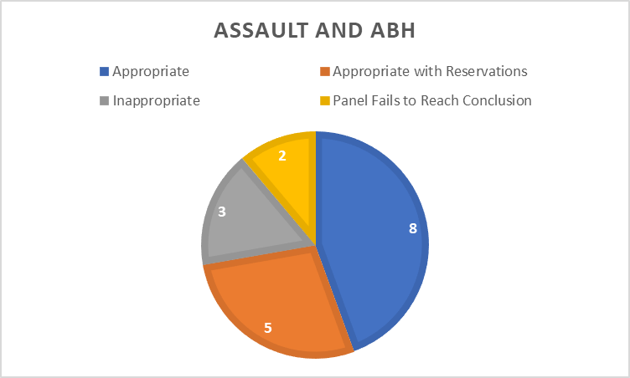
Since November 2013 the Panel has considered a range of disposals, as displayed in the graph below.
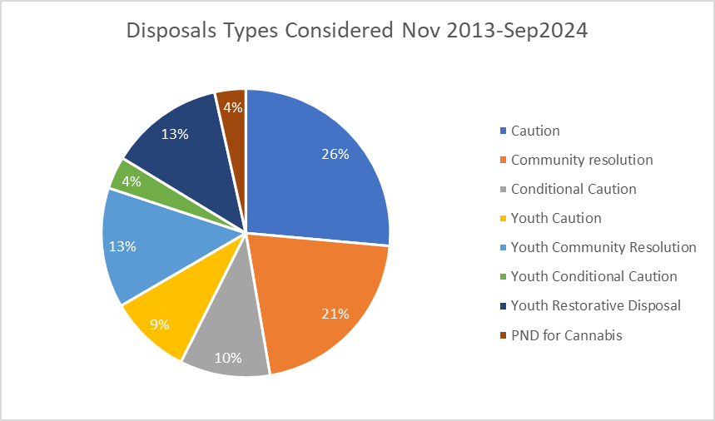
Of the 642 cases examined between November 2013 and September 2024, 57% were assessed as appropriate, 21% as inappropriate, 19% as appropriate with reservations and the panel failed to reach a conclusion in 3% of cases.
The change in conclusions reached over time can be seen in the graph below:

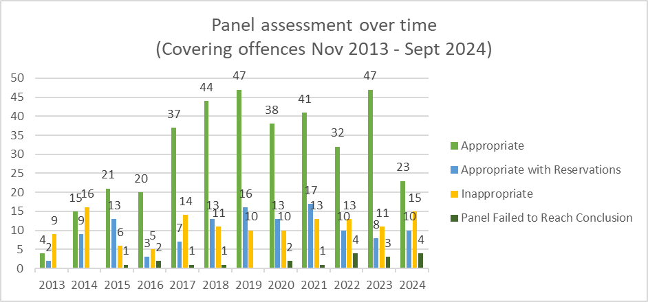
The graph below shows the breakdown by crime type as a percentage of cases considered between November 2013 and September 2024.
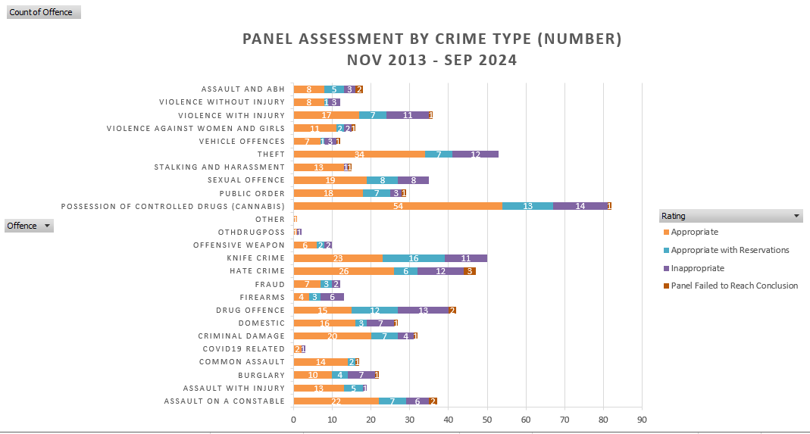

The following graph displays the actual number of cases assessed within each crime type and the resulting Panel opinions at their meetings between November 2013 and September 2024.
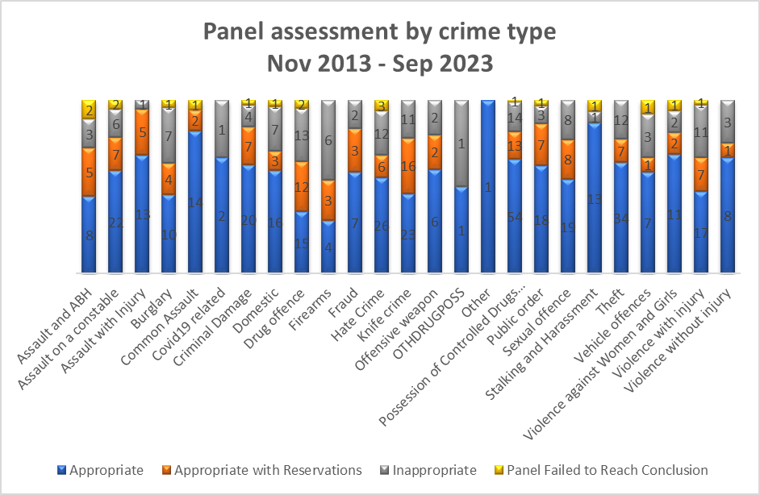

9.0 Ethnicity and Gender
The following chart shows the breakdown of cases reviewed within this meeting in terms of their gender:
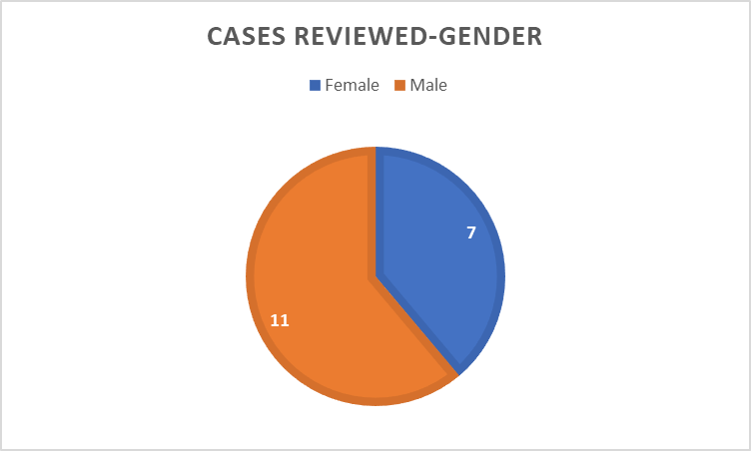

The following table shows the breakdown of cases reviewed within this meeting in terms of ethnicity.
Ethnicity Noted | Suspect’s  Self - Assessment | Officer’s Assessment
White British | 7 | 0
White – North European | 0 | 7
White | 0 | 0
Black | 0 | 0
Black African inc Black British | 0 | 0
Not stated | 0 | 0
Unknown | 0 | 0

In three of the cases reviewed, ethnicity was not recorded. There were no race or gender equality issues identified as part of the Panel’s review.

10.0 Future Panel focus
Following a discussion, it was decided by the Panel that they would like to focus on Hate Crime, Women and Girls and Disproportionality charges at the next meeting.

11.0 Actions
Meeting Date | Rec. No. | Recommendation | Person Responsible
24/04/2023 | OOCD-120 | Youth Case 6 to be marked so that any future offences are brought to court. | Judith Jenkins
17/06/2024 | OOCD-134 | When acquiring the cases from the Force, if there are additional charges, explore options to obtain a summary to assist panel’s final decision. | Tom Walters/Cedwyn Rogers/Tanya Davies
17/06/2024 | OOCD-135 | Officer involved in Adult case 1 needs to be informed of the Panel’s findings regarding the handling of a Drug and Drive offence. | Ch Insp Matthew Price
17/06/2024 | OOCD-136 | Feedback to be provided to the officer and partner agencies involved with Adult case 2 to highlight the positive work and the comprehensive report conducted. Additionally, to advise the officer of the need to provide a rationale for their decision for a Community Resolution. | Ch Insp Matthew Price
17/06/2024 | OOCD-143 | Sergeant and officer feedback to be given in relation to the findings made by the Panel for Youth 8. | Ch Insp Steve Thomas
17/06/2024 | OOCD-144 | Feedback to be provided to the local YJT in Ceredigion. Both Youth cases from the meeting in June and one Youth case from the meeting in September has meant that the Panel were unable to reach a conclusion due to no Ceredigion Bureau report. | Davinia Harries-Davies/DC Eleanor Merry
23/09/2024 | OOCD-145 | Officer and supervisor involved in Adult case 1 to be informed of the Panel’s observation of evidence led prosecution and also to be advised on ensuring that the admittance from the perpetrator is clear. | Ch Insp Steve Thomas/Insp Tom Coppock
23/09/2024 | OOCD-146 | Feedback to be provided to the officer and supervisor regarding the inappropriate use of ACC for this instance. | CI Llewllyn/ Insp Gavin Howells
23/09/2024 | OOCD-147 | Query with the Officer involved with Adult 4 whether a referral to the Diversionary Scheme was considered due to the perpetrator’s history. | CI Gareth Grant/ A-Insp Christine Beaton
23/09/2024 | OOCD-148 | Positive feedback to be provided to the supervisor regarding Adult 6 in relation to the detail of the rationale provided for the ACR. | Ch Insp Steve Thomas/Insp Tom Coppock
23/09/2024 | OOCD-149 | Feedback to officer and supervisor regarding Adult 8 in relation to the limited information in the investigation and rationale. | CI Jenna Jones
23/09/2024 | OOCD-150 | Feedback to officer and supervisor regarding Adult 9 to include more detail on what was discussed with the victim. | CI Gareth Grant/A-Insp Christine Beaton
23/09/2024 | OOCD-151 | Feedback to officer and supervisor involved in Youth 2 regarding Panel’s findings concerning limited rationale or details on the circumstances | CI Llewllyn/ Insp Gavin Howells
23/09/2024 | OOCD-152 | Feedback to officer involved with Youth 5, with regards to no explanation why the victim’s father reconsidered YRD as most appropriate. | CI Gareth Grant/A-Insp Christine Beaton

